# BUNDESLIGA DATABASE MANAGEMENT SYSTEM

**PROJECT REPORT**

# 18CSC303J – DATABASE MANAGEMENT SYSTEMS LABORATORY

**(2018 Regulation)**

**III Year/ VI Semester Academic Year: 2023 -2024** By

# SREEVATSAN.T (RA2111003011142)

Under the guidance of

# Dr. A. JEYASEKAR

**Associate Professor Department of Computing Technologies**



# COLLEGE OF ENGINEERING AND TECHNOLOGY SCHOOL OF COMPUTING

**SRM INSTITUTE OF SCIENCE AND TECHNOLOGY**

# Kattankulathur, Chengalpattu APRIL 2024

**BONAFIDE**

This is to certify that **18CSC303J – DATABASE MANAGEMENT SYSTEMS LABORATORY project report** titled “**BUNDESLIGA DATABASE MANAGEMENT SYSTEM”** is the bonafide work of **SREEVATSAN T (RA2111003011142)** who undertook the task of completing the project within the allotted time.

**Signature of the Guide** Dr. A. Jeyasekar **Associate Professor**

Dept of Computing Technologies

SRM Institute of Science and Technology

Date of Practical Exam/Venue:

Internal Examiner – 1 Internal Examiner - II

**Content Page**

|  |  |  |
| --- | --- | --- |
| **Sl No** | **Content** | **Page No** |
| 1. | Introduction | 1 |
| 2. | Project Scope and Objectives | 2 |
| 3. | Project Description | 3 |
| 4. | Back End Design  Conceptional Database Design (ER Diagram) Logical Database Design (ER Mapping) | 4 |
| 5. | Module Description | 8 |
| 6. | Relational Algebra Model for SQL used | 9 |
| 7. | Front End Design and Connectivity | 10 |
| 8. | Module-wise Coding | 12 |
| 9. | Output | 17 |
| 10. | Conclusion | 18 |
| 11. | References | 19 |

**ACKNOWLEGEMENT**

We would like to express our gratitude to Dr. A. Jeyasekar, Associate Professor, Dept of Computing Technologies, who gave us the golden opportunity to do this wonderful project on the topic **“BUNDESLIGA DATABASE MANAGEMENT SYSTEM”** which also helped us in doing a lot of research and we came to know about so many new things we are thankful to him.

We are also thankful to all the other faculty, teaching and non-teaching staff members of our department for their kind co-operation and help.

Lastly, we would also like to thank our friends who helped us a lot in finishing this project within the limited time. We are making this project not only for marks but to also increase our knowledge

SREEVATSAN T (RA2111003011142)

**ABSTRACT**

The Bundesliga Team Database Management System is a specialized platform aimed at understanding the results of individual football teams within the Bundesliga in the 2018-19 season. Focused on streamlining team-specific data management in the 2018-19 season, this system seeks to achieve objectives such as comprehensive player management and match analysis. The data types encompass player information, match analytics and team information, each defined by specific attributes and relationships. Database objects, including Player, Match, Referee, and Manager entities, are structured to support effective data organization. Key constraints, such as entity and referential integrity, check constraints, and default constraints, ensure the accuracy and consistency of team-related data. The implementation plan spans three phases, focusing on database design, CRUD operations, and advanced features, with corresponding timelines. The stakeholders include team management, coaching staff, analysts, and the IT support and maintenance team. Challenges and risks, such as data synchronization and consistency during frequent updates, are acknowledged, and future enhancements may involve data from future seasons, integrating player fitness data and implementing machine learning for predictive performance analysis. In essence, the Bundesliga Team DBMS aims to provide a tailored and efficient database management solution, ensuring teams have the necessary tools to excel in player management, match analysis, and overall administrative processes. Regular updates and future enhancements will adapt the system to the evolving needs of professional football team management.

# CHAPTER 1

# INTRODUCTION

# The Bundesliga Database Management System (BDBMS) is an innovative project designed to revolutionize the management and analysis of data pertaining to the German Bundesliga football league. With the ever-increasing importance of data-driven decision-making in sports, this system aims to provide a comprehensive platform for storing, retrieving, and analyzing various aspects of the league, ranging from player statistics and team performance to match results and managerial details. Leveraging advanced technologies and methodologies, the Bundesliga DBMS offers a user-friendly interface coupled with a robust backend infrastructure, ensuring seamless data management and access for stakeholders such as team managers, coaches, analysts, and fans. By integrating cutting-edge data analytics tools, the system enables in-depth analysis of player and team performance, facilitating strategic insights and informed decision-making processes. Real-time updates ensure that users have access to the latest information, enhancing transparency and competitiveness within the league. With its scalable architecture and customizable features, the Bundesliga DBMS adapts to evolving requirements and remains a vital tool for stakeholders in the football ecosystem. This project represents a significant step forward in the modernization of football management, empowering stakeholders with actionable insights and facilitating the optimization of performance and results in the Bundesliga league.

**CHAPTER 2**

**PROJECT SCOPE AND OBJECTIVE**

**Scope:**

The Bundesliga Team Database Management System is a specialized platform aimed at understanding the results of individual football teams within the Bundesliga in the 2018-19 season. Focused on streamlining team-specific data management in the 2018-19 season, this system seeks to achieve objectives such as comprehensive player management and match analysis. The data types encompass player information, match analytics and team information, each defined by specific attributes and relationships. Database objects, including Player, Match, Referee, and Manager entities, are structured to support effective data organization. Key constraints, such as entity and referential integrity, check constraints, and default constraints, ensure the accuracy and consistency of team-related data. The implementation plan spans three phases, focusing on database design, CRUD operations, and advanced features, with corresponding timelines. The stakeholders include team management, coaching staff, analysts, and the IT support and maintenance team. Challenges and risks, such as data synchronization and consistency during frequent updates, are acknowledged, and future enhancements may involve data from future seasons, integrating player fitness data and implementing machine learning for predictive performance analysis. In essence, the Bundesliga Team DBMS aims to provide a tailored and efficient database management solution, ensuring teams have the necessary tools to excel in player management, match analysis, and overall administrative processes. Regular updates and future enhancements will adapt the system to the evolving needs of professional football team management.

**Objectives:**

The primary objectives of the Bundesliga DBMS include:

a. Data Centralization: Aggregate diverse data sets related to teams, players, matches, and historical statistics into a single, organized database.

b. Data Accessibility: Provide user-friendly interfaces for authorized users, including league officials, team management, and analysts, to access and manipulate the data efficiently.

c. Data Security: Implement robust security measures to ensure the confidentiality, integrity, and availability of sensitive Bundesliga data.

d. Analysis and Reporting: Enable users to perform complex data analysis and generate insightful reports to support decision-making processes within the league.

# CHAPTER 3

# PROJECT DESCRIPTION

# The Bundesliga Database Management System (DBMS) is a project designed to understand the analysis of football-related data within the German Bundesliga for the 2018-19 season. This comprehensive system serves as a centralized hub for organizing, accessing, and analyzing diverse datasets, ranging from player profiles to match statistics.

# The primary objectives of the Bundesliga DBMS are to facilitate advanced analysis and reporting. The system aims to empower analysts and aspirational football fans with robust tools for informed decision-making.

# The system encompasses a range of features, including team management functionalities, detailed player profiles and comprehensive match information. It provides a holistic view of the league, offering real-time updates and historical data for teams, players, and matches.

# Player data types include personal information, performance metrics, and contractual details. Match data types cover details like dates, times, and venue information. Administrative data types focus on squad lists and transfer market data. The database implements entity integrity, referential integrity, check constraints, and default constraints to ensure data accuracy and consistency.

# The technology stack is a combination of PostgreSQL for the database, Python with the Flask framework for the backend, and HTML5, CSS3, and JavaScript with Vue.js for the frontend. Security measures such as HTTPS, encryption, and role-based access control are implemented to safeguard sensitive data.

# The project is divided into three phases. The initial phase involves database design and basic functionalities, followed by the implementation of advanced features and administrative tools. The final phase focuses on testing, user training, and documentation to ensure a smooth transition to the new system.

**CHAPTER 4**

**BACK-END DESIGN**

# Conceptual Database Design (ER Diagram)

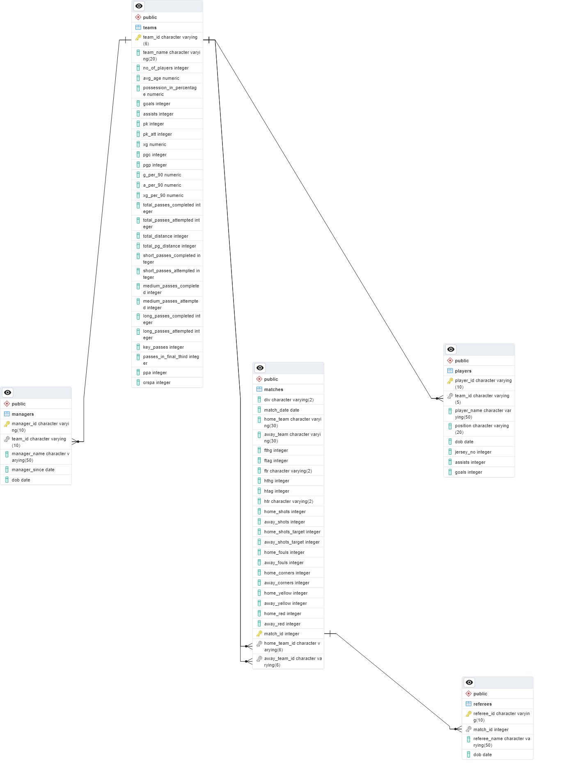

The Entity-Relationship Diagram (ERD) for the Bundesliga Database Management System illustrates the relationships between entities involved in the Bundesliga league. It includes entities such as Matches, Players, Managers, Referees, and Teams, each with its own set of attributes. Relationships between entities, such as Matches-Teams, Players-Teams, Managers-Teams, and Referees-Matches, depict how data is connected within the database. The ERD provides a concise visual representation of the database schema, facilitating understanding of the data model and its relationships.

**4.2 Logical Database Design (ER Mapping)**

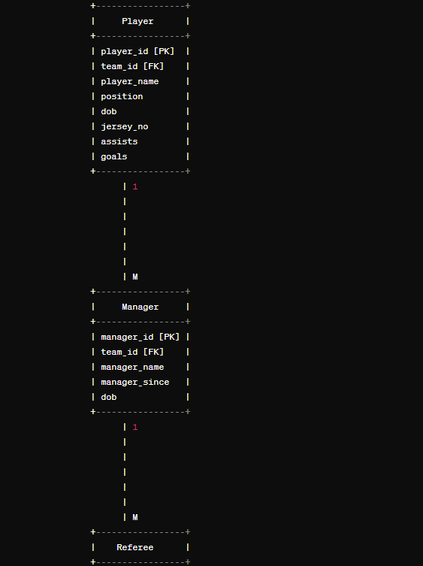

# The Bundesliga Database Management System consists of several interconnected modules, each serving a specific purpose in managing and analyzing data related to the Bundesliga league. The Matches module handles information pertaining to individual matches, including match date, participating teams, scores, shots, fouls, and cards. The Players module manages data about players, such as their personal details, positions, jersey numbers, assists, and goals. In parallel, the Managers module oversees details of team managers, including their names, tenure with the team, and date of birth. The Referees module tracks information about match officials, such as their names and dates of birth. Lastly, the Teams module stores data concerning Bundesliga teams, encompassing team names, player counts, performance metrics like goals per 90 minutes and total distance covered. Each module is interconnected through relationships, allowing seamless retrieval and analysis of data within the Bundesliga ecosystem.

# CHAPTER 5

# MODULE DESCRIPTION

Each module serves a specific purpose within the database, facilitating the management and analysis of different aspects of the Bundesliga league, including matches, players, managers, referees, and teams. The modules are interconnected through foreign key relationships, ensuring data integrity and enabling efficient retrieval and analysis of information.

1. Matches Module:

This module manages information related to matches played in the Bundesliga league.

It includes attributes such as match date, home team, away team, goals scored by home team (fthg), goals scored by away team (ftag), result (ftr), halftime goals, halftime result, shots, fouls, corners, yellow cards, and red cards for both home and away teams. Additional attributes include division (div) and identifiers for the home and away teams (home_team_id, away_team_id).

1. Players Module:

This module stores data about players participating in the Bundesliga. Attributes include player ID, team ID (foreign key referencing the Teams module), player name, position, date of birth, jersey number, assists, and goals.

1. Managers Module:

Manages information about team managers in the Bundesliga. Attributes consist of manager ID, team ID (foreign key referencing the Teams module), manager name, date since when they are managing the team, and date of birth.

1. Referees Module:

Handles details of referees officiating matches. Contains attributes like referee ID, match ID (foreign key referencing the Matches module), referee name, and date of birth.

1. Teams Module:

Stores data related to Bundesliga teams. Attributes include team ID, team name, number of players, goals per 90 minutes (g_per_90), expected goals per 90 minutes (xg_per_90), and total distance covered.

**CHAPTER 6**

**RELATIONAL ALGEBRA MODEL FOR SQL USED**

The following relations are used:

1. Matches (MatchID, Division, MatchDate, HomeTeam, AwayTeam, FTHG, FTAG, FTR, HTHG, HTAG, HTR, HomeShots, AwayShots, HomeShotsTarget, AwayShotsTarget, HomeFouls, AwayFouls, HomeCorners, AwayCorners, HomeYellow, AwayYellow, HomeRed, AwayRed, HomeTeamID, AwayTeamID)
2. Players (PlayerID, TeamID, PlayerName, Position, DOB, JerseyNo, Assists, Goals)
3. Managers (ManagerID, TeamID, ManagerName, ManagerSince, DOB)
4. Referees (RefereeID, MatchID, RefereeName, DOB)
5. Teams (TeamID, TeamName, NoOfPlayers, GPer90, XGPer90, TotalDistance)

The relational algebra operations used for various queries could include:

1. Selection: Used to filter rows based on certain conditions. For example:

σ(HomeTeam='Bayern Munich' AND AwayYellow=4)(Matches)

σ(HomeTeam='Leverkusen')(Matches)

σ(HomeShots > AVG(HomeShots))(Matches)

1. Projection: Used to select specific columns from a relation. For example:

π(HomeTeam, COUNT(*))(Matches)

π(AwayTeam, MAX(AwayYellow))(Matches)

π(HomeTeam, MAX(HomeShots))(Matches)

1. Join: Used to combine tuples from two relations based on a related attribute. For example:

⨝Matches.HomeTeamID=Teams.TeamID(Matches ⨝ Teams)

⨝Referees.MatchID=Matches.MatchID(Referees ⨝ Matches)

⨝Players.TeamID=Teams.TeamID(Players ⨝ Teams)

1. Union: Used to combine the results of two queries that have the same attributes. For example:

Union of two selections: σ(HomeTeam='Bayern Munich')(Matches) ∪ σ(AwayTeam='Bayern Munich')(Matches)

# CHAPTER 7

# FRONT END DESIGN AND CONNECTIVITY

<!DOCTYPE html>

<html lang="en">

<head>

<meta charset="UTF-8">

<meta name="viewport" content="width=device-width, initial-scale=1.0">

<title>Bundesliga Database Management System - Login</title>

<style>

body {

font-family: Arial, sans-serif;

background-color: #f2f2f2;

}

.login-container {

width: 300px;

margin: 0 auto;

padding: 20px;

background-color: #fff;

border-radius: 5px;

box-shadow: 0 0 10px rgba(0, 0, 0, 0.1);

margin-top: 100px;

}

h2 {

text-align: center;

margin-bottom: 20px;

}

input[type="text"],

input[type="password"] {

width: 100%;

padding: 10px;

margin-bottom: 15px;

border: 1px solid #ccc;

border-radius: 3px;

box-sizing: border-box;

}

input[type="submit"] {

width: 100%;

padding: 10px;

background-color: #007bff;

color: #fff;

border: none;

border-radius: 3px;

cursor: pointer;

}

input[type="submit"]:hover {

background-color: #0056b3;

}

</style>

</head>

<body>

<div class="login-container">

<h2>Bundesliga Database Management System</h2>

<form action="login.php" method="post">

<input type="text" name="username" placeholder="Username" required>

<input type="password" name="password" placeholder="Password" required>

<input type="submit" value="Login">

</form>

</div>

</body>

</html>

**CHAPTER 8**

**MODULEWISE CODING**

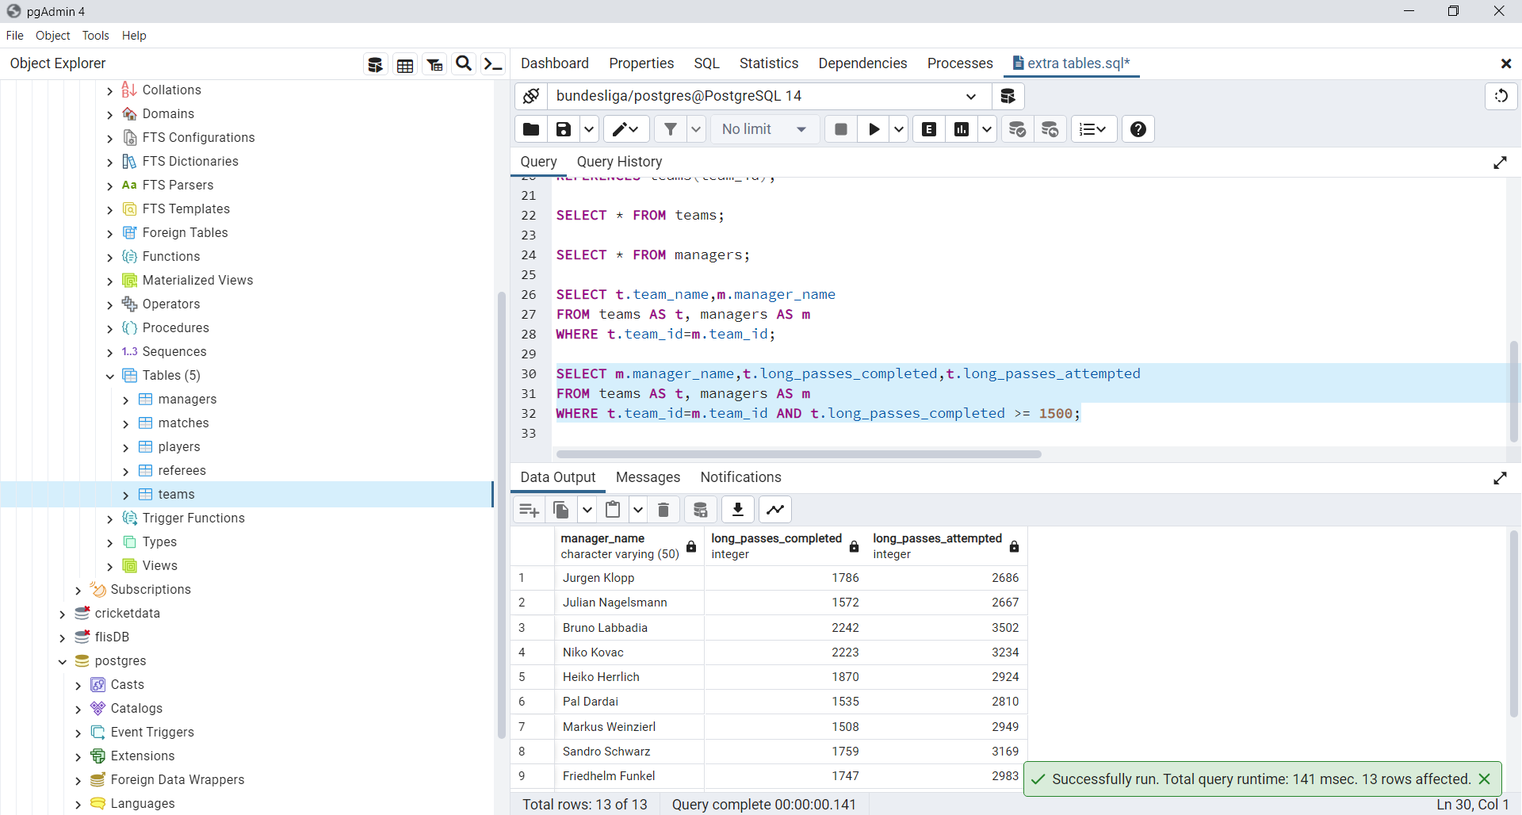

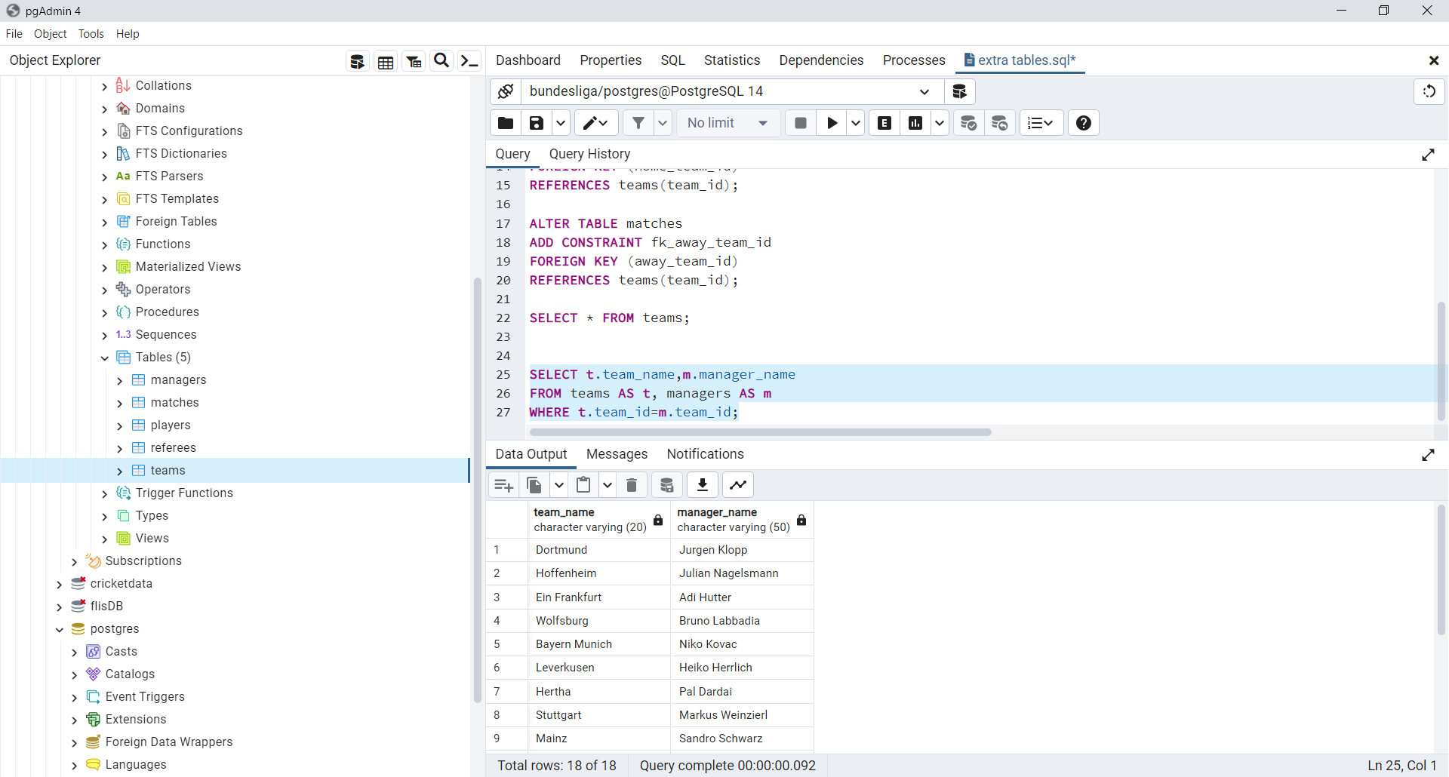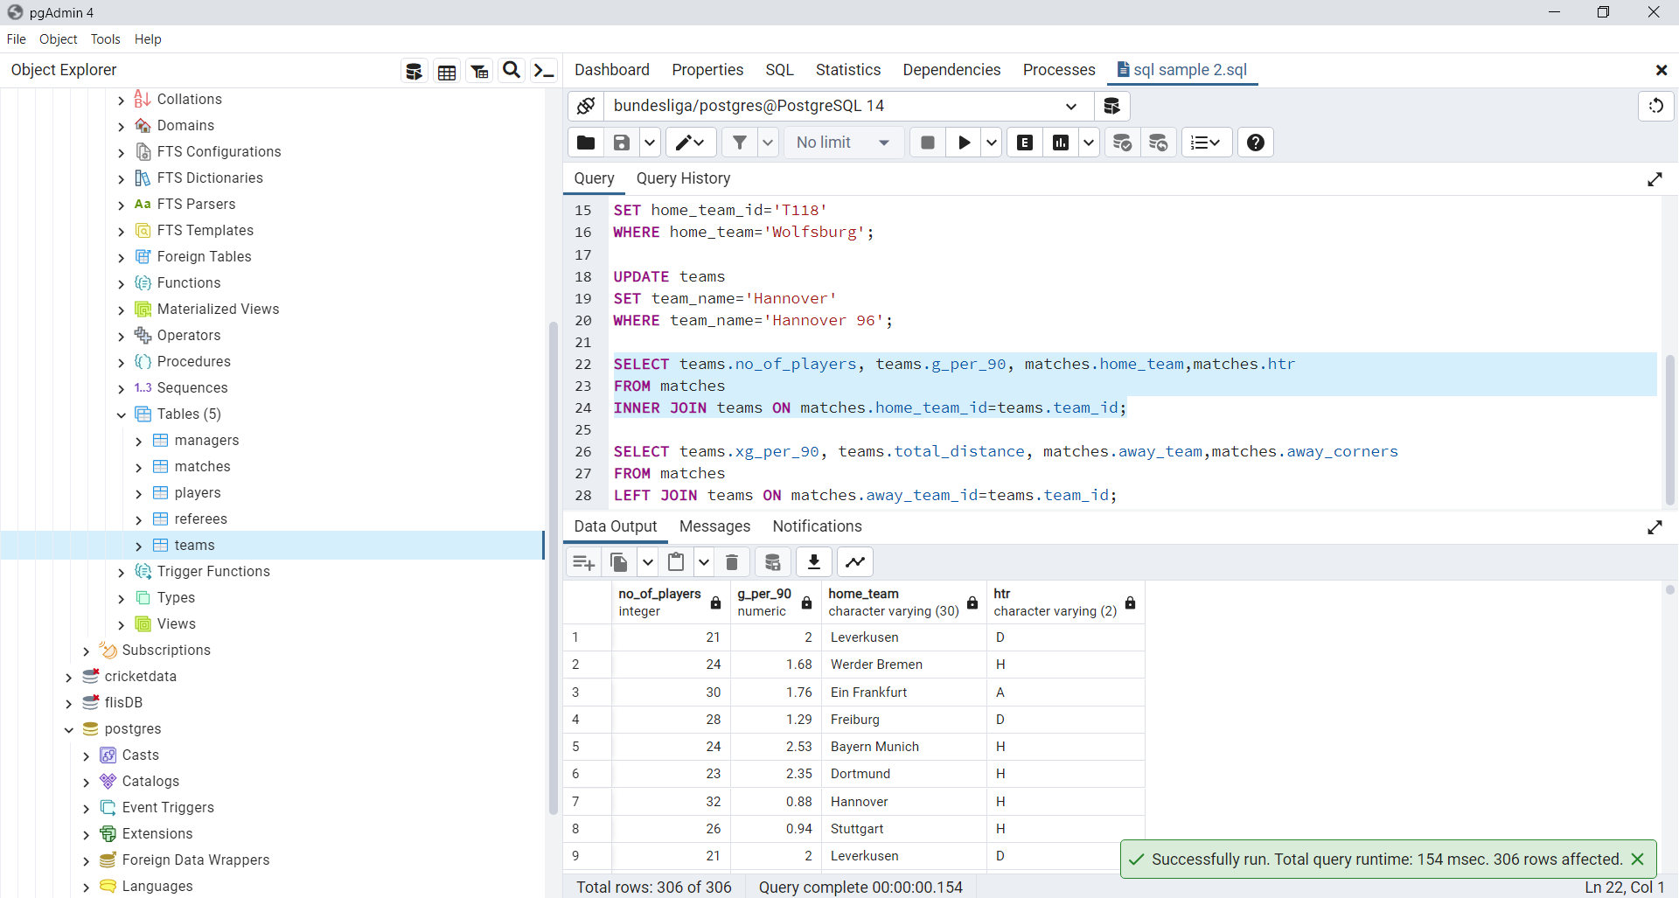

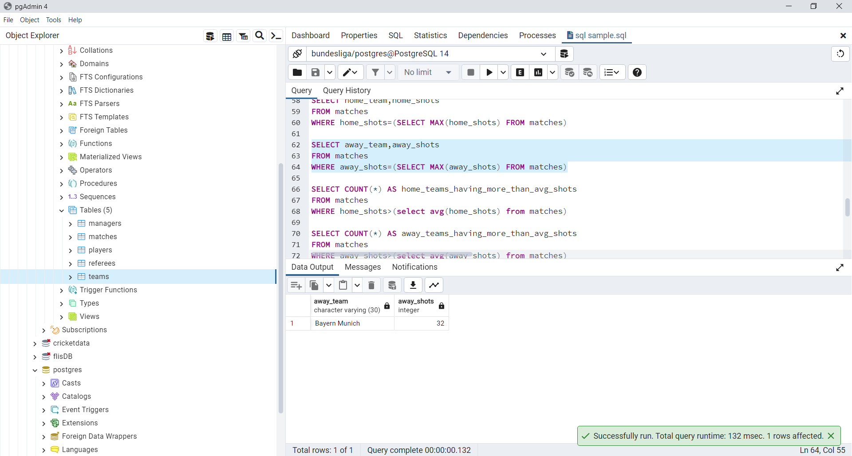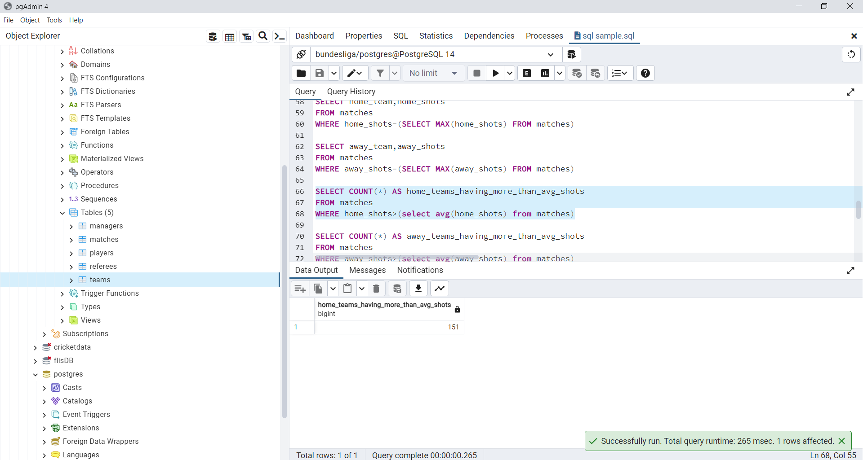

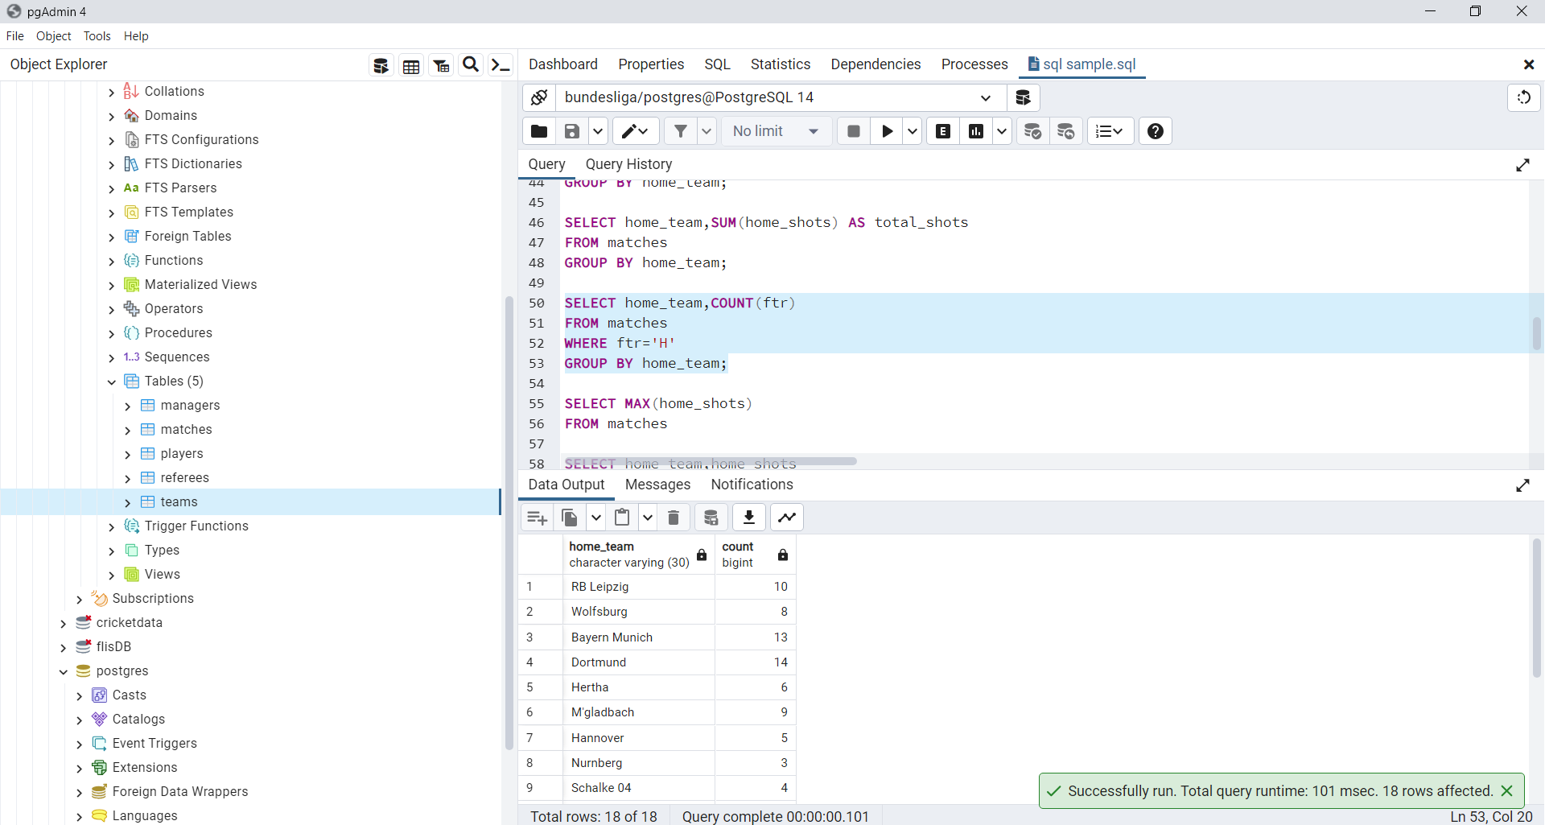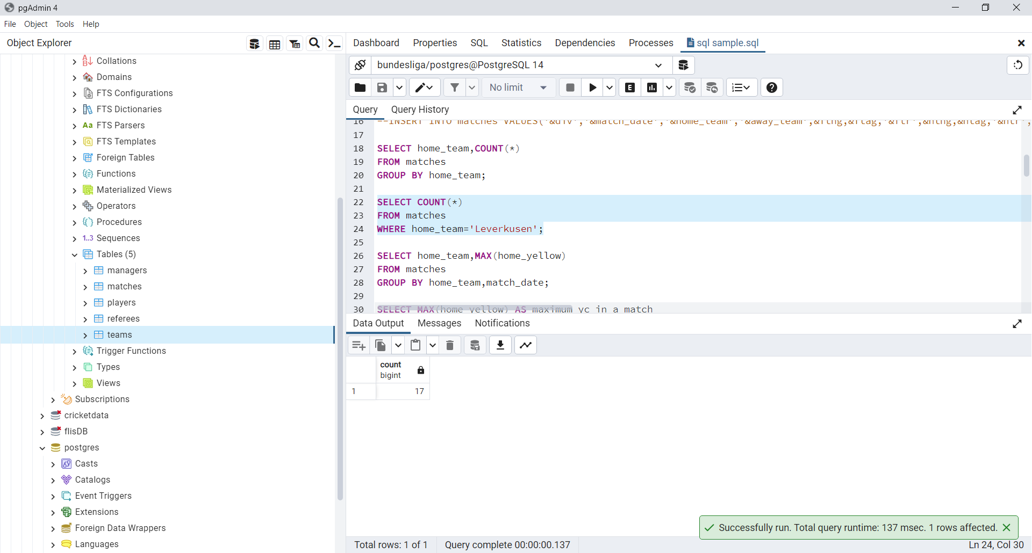

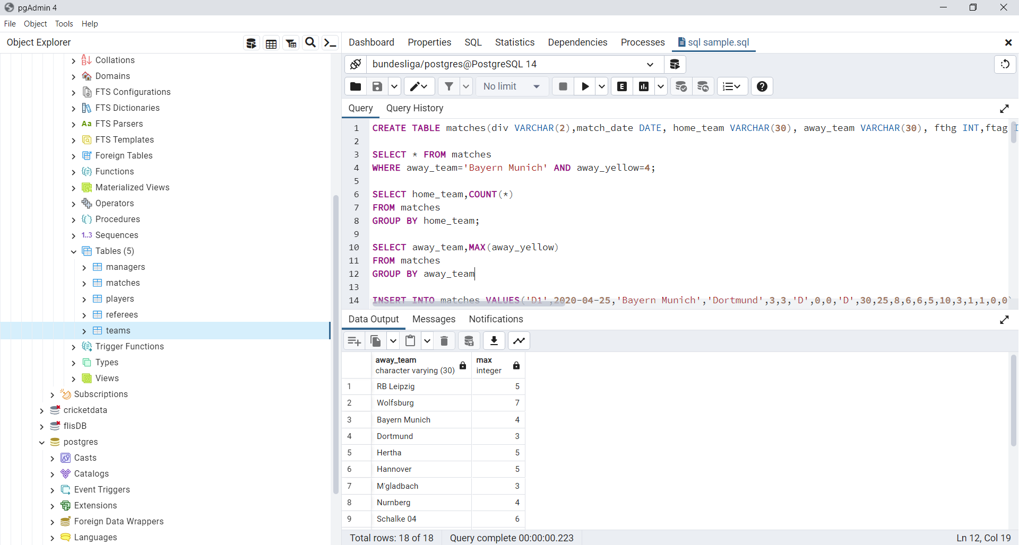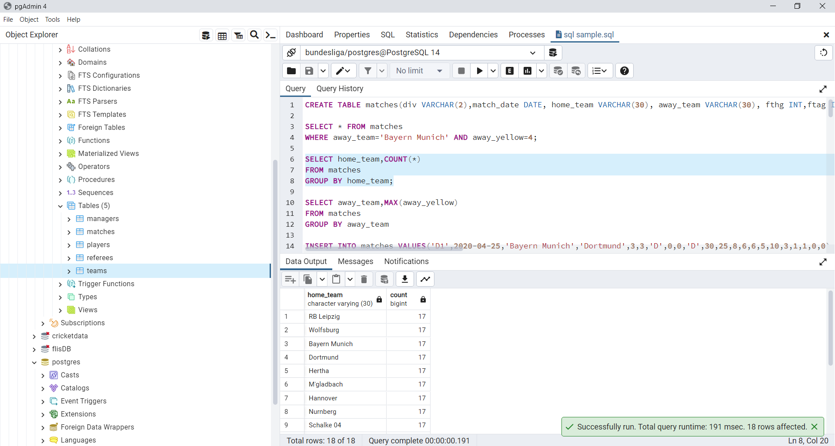

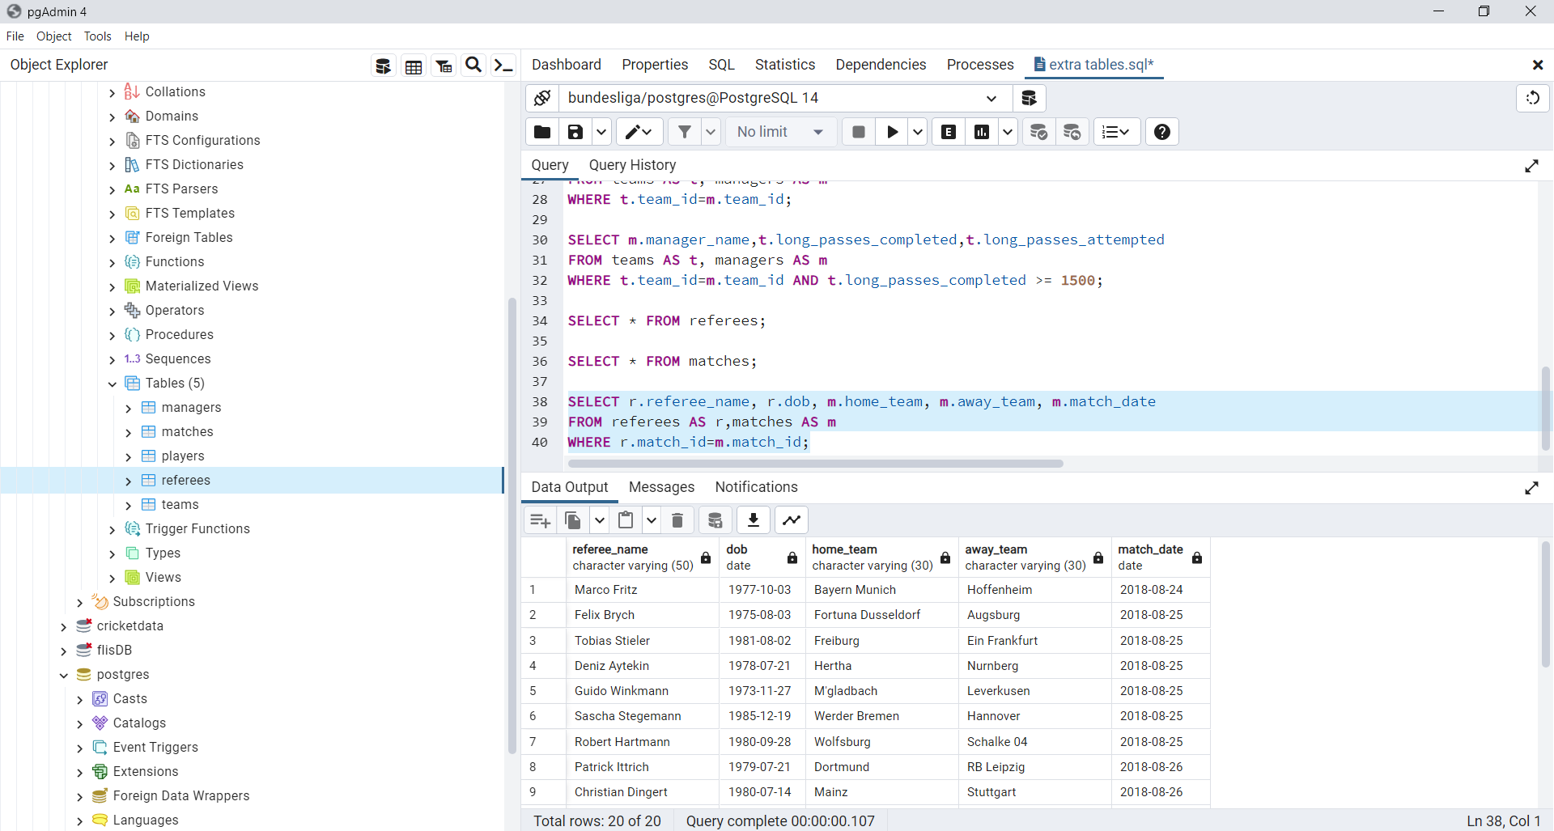

# OUTPUT

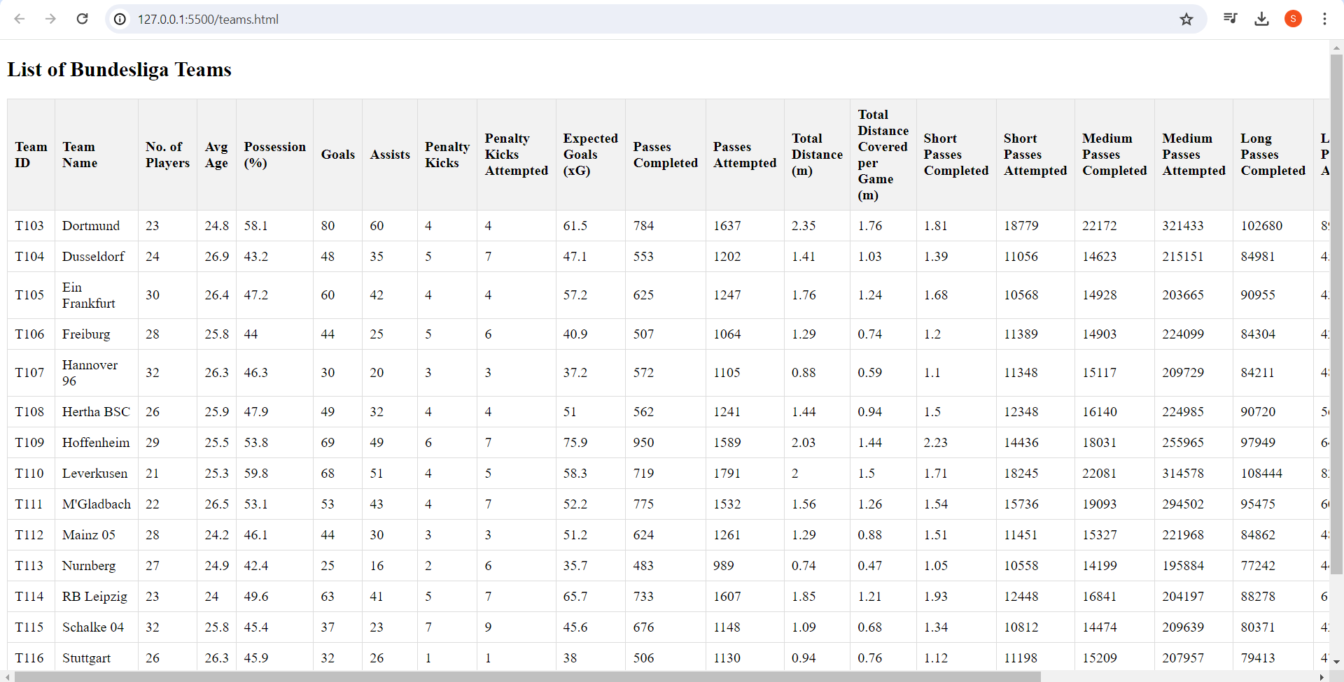

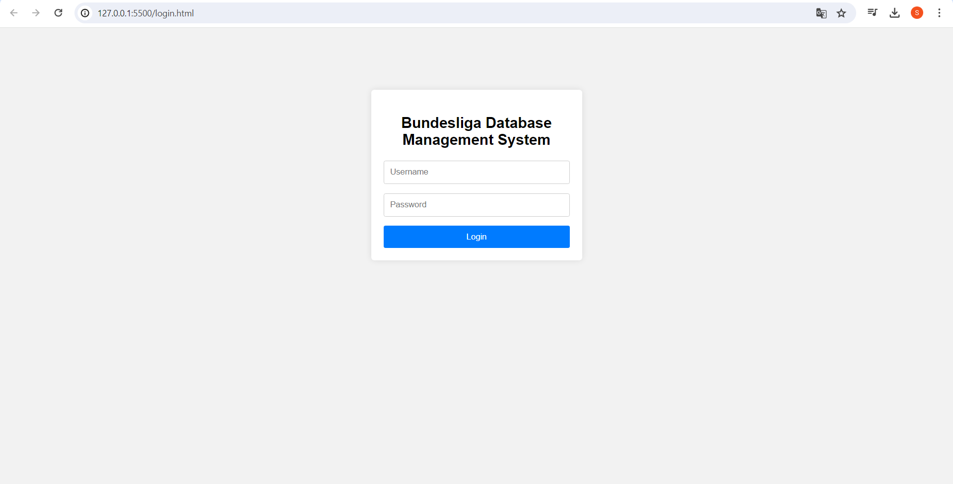

**CONCLUSION**

The Bundesliga Database Management System provides a comprehensive platform for managing various aspects of the Bundesliga football league. From player and team statistics to match details and referee information, the database covers a wide range of data essential for analyzing and understanding the performance and dynamics of teams and players in the league.

Through the project, we've established a relational database schema that captures the relationships between entities such as teams, players, matches, managers, and referees. This schema allows for efficient storage and retrieval of data while maintaining data integrity through foreign key constraints.

Additionally, we've implemented various SQL queries and procedures to perform operations such as retrieving average statistics, updating data, and generating reports. These functionalities enable users to gain insights into team and player performances, track match outcomes, and analyze referee performance.

The HTML interface provides a user-friendly front end for interacting with the database, allowing users to view team data in a structured and organized manner. By displaying key statistics such as possession percentage, goals, assists, and more, the interface facilitates easy access to vital information for stakeholders such as coaches, analysts, and fans.

Overall, the Bundesliga Database Management System serves as a valuable tool for stakeholders involved in the Bundesliga football league, empowering them to make data-driven decisions, analyze trends, and gain deeper insights into the performance and dynamics of teams and players throughout the season.

**REFERENCES**

W3Schools SQL Tutorial: A comprehensive online tutorial covering SQL basics, advanced queries, and database management concepts.

PostgreSQL Documentation: The official documentation for PostgreSQL, providing detailed information on SQL syntax, data types, and database administration.

Research Papers: Academic papers on database design principles and best practices can provide valuable insights into creating efficient database schemas and optimizing database performance.

Papers or articles on sports analytics and data-driven decision-making in sports management can offer ideas for incorporating statistical analysis into the project.

Bundesliga Official Website: The official website of the Bundesliga can provide information on league structure, team rosters, match schedules, and other relevant data that can be used to populate the database.

Data Analytics Blogs and Websites: Blogs and websites focused on data analytics and sports analytics may offer articles, case studies, and tutorials relevant to the project, providing insights into analyzing sports data and deriving meaningful insights.